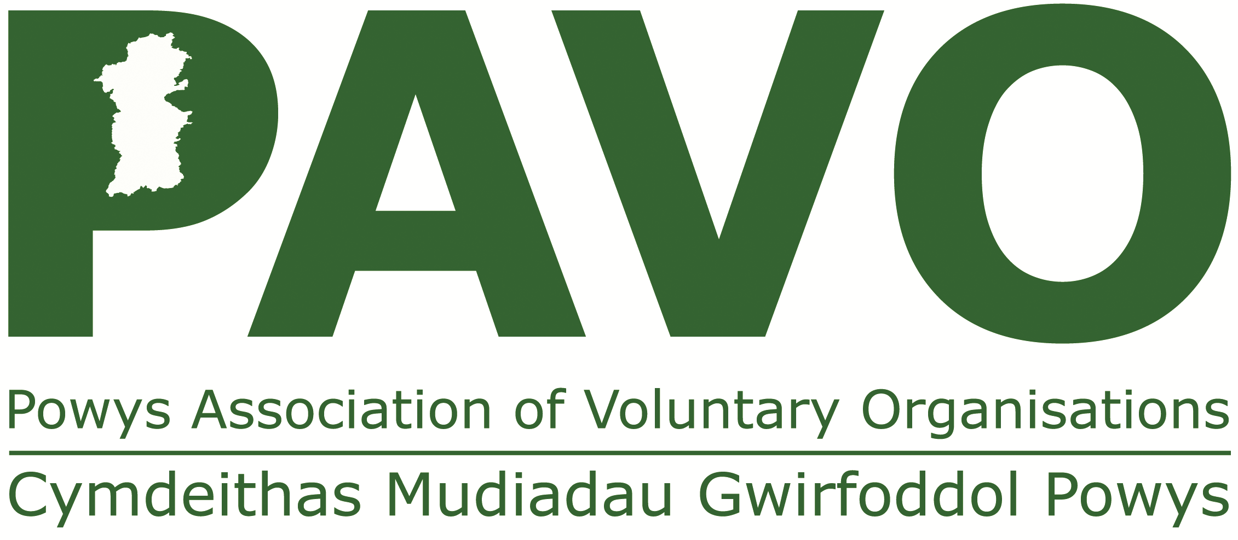

30 Ddole Road Industrial Estate, Llandrindod Wells, Powys LD1 6DF
Charity Registration No. 1069557 Telephone: 01597 822191

APPLICATION FORM

APPLICATION FORM

Please complete all sections of the form in black ink. Do not enclose a CV.

Position applied for:
Development Officer - Community Rail (The Cambrian Railway Partnership Line)

Closing date for applications:
Closing date: Noon Tuesday 26th November 2024

Reference Number:
N/A

SECTION A PERSONAL INFORMATION

Please note: Personal information will not be used for shortlisting purposes.

Name:

Address:

email: _____

Tel No: day: evening: __________________________

May we contact you at work? Yes No

Are there any dates w/c 09/12/2024 you would not be available for interview? (If yes, please state dates)
Yes No

REFERENCES

Please give the name of two referees, one of whom should be your current or last employer. The people given as referees will normally not be contacted until the shortlisting process has been completed.

1. Name:_________________________________________________________

Address:_______________________________________________________
_______________________________________________________________
Tel:___________________________email____________________________

How is this person known to you?

____________________________________________________

2. Name:_________________________________________________________

Address:_______________________________________________________
_______________________________________________________________
Tel:___________________________email____________________________

How is this person known to you?

____________________________________________________

Can these people be contacted prior to interview? Yes No

I confirm that all the information I have given in this form is correct and complete and will form the basis on which any offer of employment is made.

I understand that PAVO has the right to terminate employment where it is discovered that I have provided false information in any material respect.

Signature

Date

SECTION B

Make use of the person specification and job description as a guide when completing this section, demonstrating fully how you meet each of the requirements of the role.

EXPERIENCE AND EDUCATION

Education, technical and professional qualifications

Please list any qualifications that you feel are relevant to this post as detailed in the job description.

Personal Development

Please list any courses, membership, voluntary work or responsibilities that you feel relevant to this post as detailed in the job description, with outcomes where applicable.

Employment History

Do you currently work or have you in the past worked for PAVO? Yes □ No □

Please begin with present or most recent employment. We understand that you may have career gaps for various reasons; please ensure that you account for all career gaps, eg, raising a family, caring for a relative, gap years etc. This will not affect our shortlisting decision.

Employer – name and full address | Job title/key achievements | Salary | Length of time in post and  Reasons for leaving

KNOWLEDGE AND SKILLS
Please show how your knowledge, experience, skills and abilities will enable you to carry out the tasks required for this post. Make full use of the job description and person specification, detailing how you meet each of the requirements.
This information will form a major part of the shortlisting decision.

Please continue on additional sheets as necessary.

Do you have the ability to travel round rural Powys? Yes No

Do you hold a full current driving licence? Yes No

What is your level of competency in the Welsh Language?

Please tick the statement that most closely represents your Welsh Language ability. The minimum requirement for the post is set out in the person specification section of the job description, but we welcome applicants whose ability exceeds that minimum requirement.

0. Very little or no knowledge of Welsh.

- I can pronounce Welsh personal and place-names correctly, and I can give and
respond to basic greetings on the telephone or in person.

- I can communicate routine tasks requiring a simple exchange of information on familiar topics and activities. I can handle very short social exchanges, even though I can't usually understand enough to keep the conversation going myself.

- I can deal with most situations likely to arise whilst travelling in an area where the language is spoken. I can enter unprepared into conversation on topics that are familiar or pertinent to everyday life (e.g. family, hobbies, work).

- I can interact with a degree of fluency and spontaneity that makes interaction with native speakers possible. I can take an active part in discussion in familiar contexts.

- I can take part effortlessly in any conversation or discussion and have a good familiarity with idiomatic expressions and colloquialisms. I can express myself fluently and convey finer shades of meaning precisely.

Do you have any criminal convictions, excluding any considered ‘spent’ under the Rehabilitation of Offenders Act 1974 (minor motoring offences should be disregarded)? Yes No

If you answered yes, please give details in the box below.

Are there any adjustments that are needed, should you be shortlisted, to make the interview more accessible for you? If so, please give details:-

Please return completed form by Noon on 26/11/2024 to:
recruitment@pavo.org.uk
Powys Association of Voluntary Organisations
30 Ddole Road, Llandrindod Wells, Powys, LD1 6DF

